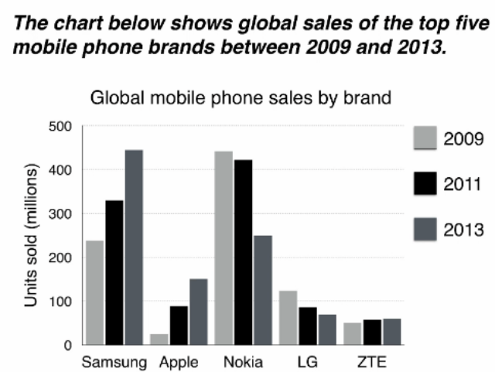

该柱状图显示了2009年、2011年、2013年这三年五家领先厂商手机销量变化情况。总的来说，虽然诺基亚和LG的手机销量有所下降，但其他三家公司的手机销量却在不同程度上有所增加，最终三星成为最受欢迎的品牌。

The bar graph illustrates how the sales of mobile phones of the five leading manufacturers changed in three years: 2009, 2011, 2013.
The bar chart shows the number of worldwide sales of the top five bestselling smartphone brands from 2009 to 2013.

Overall, while Nokia and LG saw a decline in the sales of mobile phones, the other three companies sold more mobile phones to varying degrees, with Samsung becoming the most popular brand in the end.

表示最大值：XX dominated the market / was the most preferred choice / sold the most mobile phones / became the most popular brand among consumers

范文1: 主体段按趋势分，把下降的Nokia, LG分为一组，上升的Samsung, Apple, ZTE分为一组

In 2009, Nokia sold about 420 million mobile phones, a figure that was far higher than those for other brands. However, this number dropped a little in 2011 and then collapsed to about 250 million in 2013. LG witnessed a similar trend, whose sales decreased from around 110 million to about 80 million during the same period.

On the other hand, the products of the other three mobile phone producers became more favored. The sales of Samsung grew dramatically from approximately 240 million in 2009 to roughly 450 million in 2013, which was much higher than the statistics of the other brands. Also, Apple’s sales rose steadily from an insignificant level to around 150 million in 2013. ZTE sold the fewest mobile phones, with its number climbing slightly to about 50 million in 2013.

范文2: 数值大的Samsung和Nokia分为一组，写在同一个主体段

In 2009, Samsung sold close to 250 million phones, nearly half of the number of handsets sold by Nokia, the most sales for the year. Over the following four years, Nokia's sales figures had experienced a marked drop by almost 200 million, while Samsung saw its sales rise (saw a rise in sales) to roughly 350 million in 2011 and eventually reached its peak at 450 units, replacing Nokia as the market leader.
(表示目的数值：increase to = reach，到达最高点/最低点可用reach its peak/low at ..)

As for the other three brands, their sales were relatively low. During this period, the figure for LG declined from over 100 million units to about 70 million units. However, the popularity of Apple’s products surged, with its sales reaching about 150 million units. Similarly, the number of mobile phones sold by ZTE increased slightly to around 60 million units. .

